



iProject Report

FY **2020**

**[Scrap Collector]**

MUHAMMAD HARIS #1071544 BatchCode::#201710b1

|  |  |  |
| --- | --- | --- |
|  |  |  |
|  |  |  |
|  |  |  |

***Aptech Shahr-e- Faisal (FSO),Karachi,Pakistan***

Contents

Acknowledgement 1

iProject Synopsisy 2

iProject Analysis 5

iProject Design 6

Entity Realtionship Diagram 7

Database Schema 8

Screen Shots 12

Project CheckList 23

# AKNOWLEDGEMENTS

By the Grace of Almighty Allah, We have successfully complete our project with the help of over hardworking and devoted teachers. Now we are presenting a marvelous project (php).For your kind information our project is a complete code of technology.

This is our first attempt. We tried to our best. This project has developed with the help of “PHP/ HTML / CSS / Java Script/JQuery ” our task to make a project for entertaining for Project we used Atom IDE software for Coding.

We hope that this project will be very fruitful for the user and upcoming generation of the world. We will wait for your suggestion for further improvement positively.

**MUHAMMAD HARIS**

**StdID#1071544**

# iProject Synopsis

**Title** “Scrap Collector“ -web application

**Problem Statement**

Scrap Collector is Web based Online Portal for door to door Free Scrap Collection and Recycling Service. Scrap Collector Provides different Sectors which include Individual House, Society, Organizations and Industries. Give away your recyclables used paper, plastic, metal, glass etc. in a most environment friendly manner.

**PURPOSE**

Scrap Collector (SC) is the first App for door to door Free Scrap Collection and Recycling Service.

Scrap collector brings transparency to the age-old ways of waste paper collection. We have introduced the use of electronic weighing scales at the doorsteps of clients. Our First Priority at scrap collector is Customer Satisfaction which we try to achieve by giving the Best Price, Accurate Weight (Electronic Weighting Machine) and 100% assurance of Recycling the Scrap Material Provided by our Customers. We purchase waste paper of all kinds at a fair price, including newspapers, notebooks, magazines, steel, brass, glass, iron, plastic, etc. We make use of technology in the whole process of collecting waste. Give away your recyclables used paper, plastic, metal, glass etc. in a most environment friendly manner. We have a centralized call center, and our mobile workforce uses tablet PCs for submitting their transactions. This enables trust among common people. We also take waste collection bookings through text messages.

**PROPOSED SYSTEM**

We face many difficulties when we have to sell our scrap but this app will solve this problem. We don’t have to wait for scrap collector any more. Its digital world so this application provides digital way to sell our scrap.

In this application scrap collector will comes to our lives and collect the scrap. Here we don’t have to wait for scrap collector or we don’t need to go for sell the scrap. Here scrap collector comes when we call them according to our convenience and collect all the scrap and give money at that time.

This application will guarantee that scrap will be collected within 24 hours. There is no cheating in this, weight will be measured in electronic weight machine.

**ADVANTAGES OF PROPOSED SYSTEM**

Time-saving

Ease of Use and Implementation

It is useful for booking appointments.

**Resources** To complete this project we required the following resources:

**Hardware**

* A minimum computer system that will help you access all the tools in the courses is a Pentium 166 or better
* 256 Megabytes of RAM or better
* Windows 2000 (or higher if possible)

**Software**

**Either or combination of the following Software’s are to be used:**

* Atom IDE/HTML editor
* MySql
* IE 5.0/ CHROME
* XAMPP server
* Jquery Framework

# iProject Analysis

**Project Functional Requirements Specification:**

User (admin, customer, scrap collector) can easily operate the application.

**Admin:**

* Add scrap collectors.
* Can create various scraps item and update the rates in the master database.
* View total scrap collected item wise for a day, month or date range.
* View all appointments.
* Assign appointments to scrap collector.
* Check user wise reports
* Check scrap collector wise reports

**User:**

* Register for the service with proper details
* Book appointment for scrap collection.
* Check rates of various items.
* Generate reports of current and previous selling’s

**Scrap Collector:**

* Register with the app with proper details
* View assigned appointments.
* Provide weighed scrap details item wise in portal/database.

**Project recommended Solution :**A web application which fullfill all the above requirments,

***iProject Design***

# iProject Design-ERD

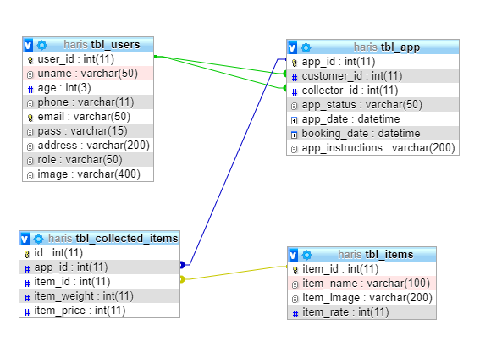

# iProject Design-DATABASE Structure/schema

CREATE TABLE `tbl_app` (

`app_id` int(11) NOT NULL,

`customer_id` int(11) NOT NULL,

`collector_id` int(11) DEFAULT NULL,

`app_status` varchar(50) DEFAULT NULL,

`app_date` datetime DEFAULT NULL,

`booking_date` datetime DEFAULT current_timestamp(),

`app_instructions` varchar(200) NOT NULL DEFAULT 'no instructions'

) ;

**CREATE TABLE `tbl_collected_items`** (

`id` int(11) NOT NULL,

`app_id` int(11) NOT NULL,

`item_id` int(11) NOT NULL,

`item_weight` int(11) NOT NULL,

`item_price` int(11) NOT NULL

)

**CREATE TABLE `tbl_items` (**

`item_id` int(11) NOT NULL,

`item_name` varchar(100) NOT NULL,

`item_image` varchar(200) NOT NULL DEFAULT 'noimage.png',

`item_rate` int(11) NOT NULL

) ;

**CREATE TABLE `tbl_users`** (

`user_id` int(11) NOT NULL,

`uname` varchar(50) NOT NULL,

`age` int(3) NOT NULL,

`phone` varchar(11) NOT NULL,

`email` varchar(50) NOT NULL,

`pass` varchar(15) NOT NULL,

`address` varchar(200) NOT NULL,

`role` varchar(50) DEFAULT NULL,

`image` varchar(400) NOT NULL DEFAULT 'default.png'

)

**ALTER TABLE `tbl_app`**

ADD PRIMARY KEY (`app_id`),

ADD KEY `customer_id` (`customer_id`),

ADD KEY `collector_id` (`collector_id`);

A**LTER TABLE `tbl_collected_items`**

ADD PRIMARY KEY (`id`),

ADD KEY `app_id` (`app_id`),

ADD KEY `item_id` (`item_id`);

**ALTER TABLE `tbl_items`**

ADD PRIMARY KEY (`item_id`);

**ALTER TABLE `tbl_users`**

ADD PRIMARY KEY (`user_id`),

ADD UNIQUE KEY `email` (`email`);

**ALTER TABLE `tbl_app`**

MODIFY `app_id` int(11) NOT NULL AUTO_INCREMENT, AUTO_INCREMENT=12;

**ALTER TABLE `tbl_collected_items**`

MODIFY `id` int(11) NOT NULL AUTO_INCREMENT, AUTO_INCREMENT=62;

**ALTER TABLE `tbl_items`**

MODIFY `item_id` int(11) NOT NULL AUTO_INCREMENT, AUTO_INCREMENT=10;

**ALTER TABLE `tbl_users`**

MODIFY `user_id` int(11) NOT NULL AUTO_INCREMENT, AUTO_INCREMENT=18;

**ALTER TABLE `tbl_app`**

ADD CONSTRAINT `tbl_app_ibfk_1` FOREIGN KEY (`customer_id`) REFERENCES `tbl_users` (`user_id`),

ADD CONSTRAINT `tbl_app_ibfk_2` FOREIGN KEY (`collector_id`) REFERENCES `tbl_users` (`user_id`);

**ALTER TABLE `tbl_collected_items`**

ADD CONSTRAINT `tbl_collected_items_ibfk_1` FOREIGN KEY (`app_id`) REFERENCES `tbl_app` (`app_id`),

ADD CONSTRAINT `tbl_collected_items_ibfk_2` FOREIGN KEY (`item_id`) REFERENCES `tbl_items` (`item_id`);

**COMMIT;**

***iProject***

***Screen Shots***

# iProjects Screenshots

**WEBSITE HOME PAGE:**

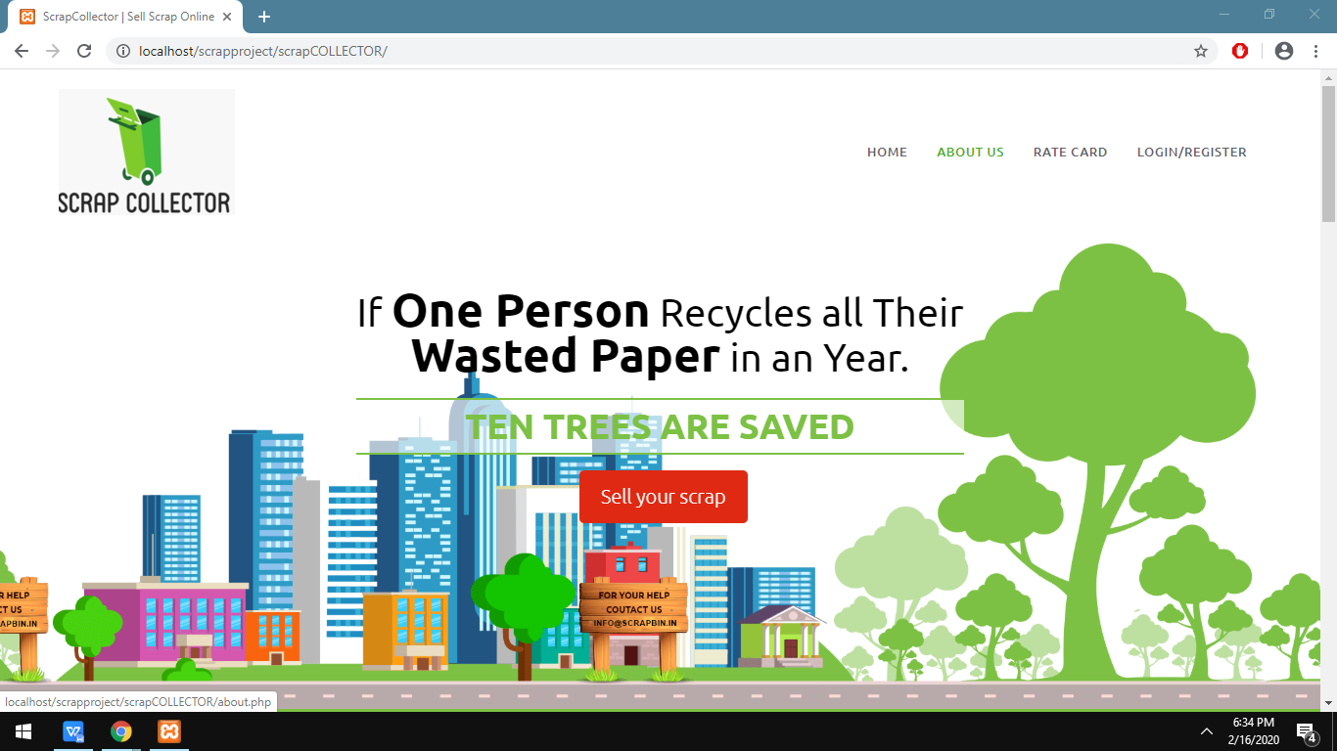

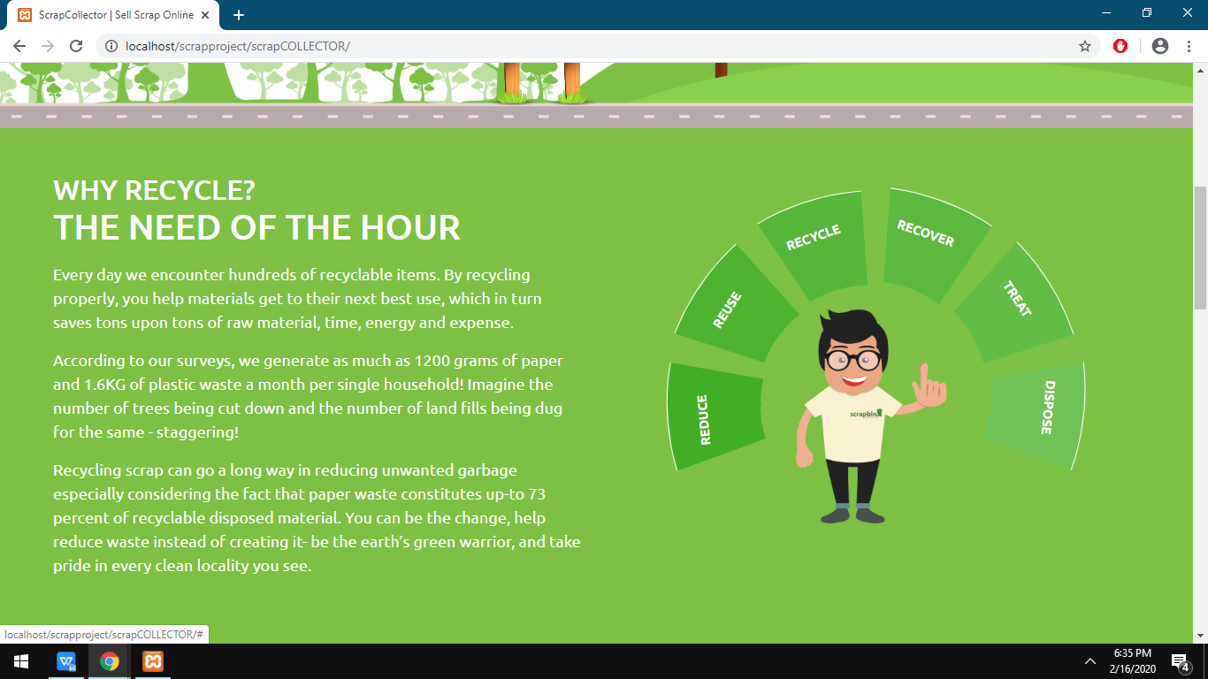

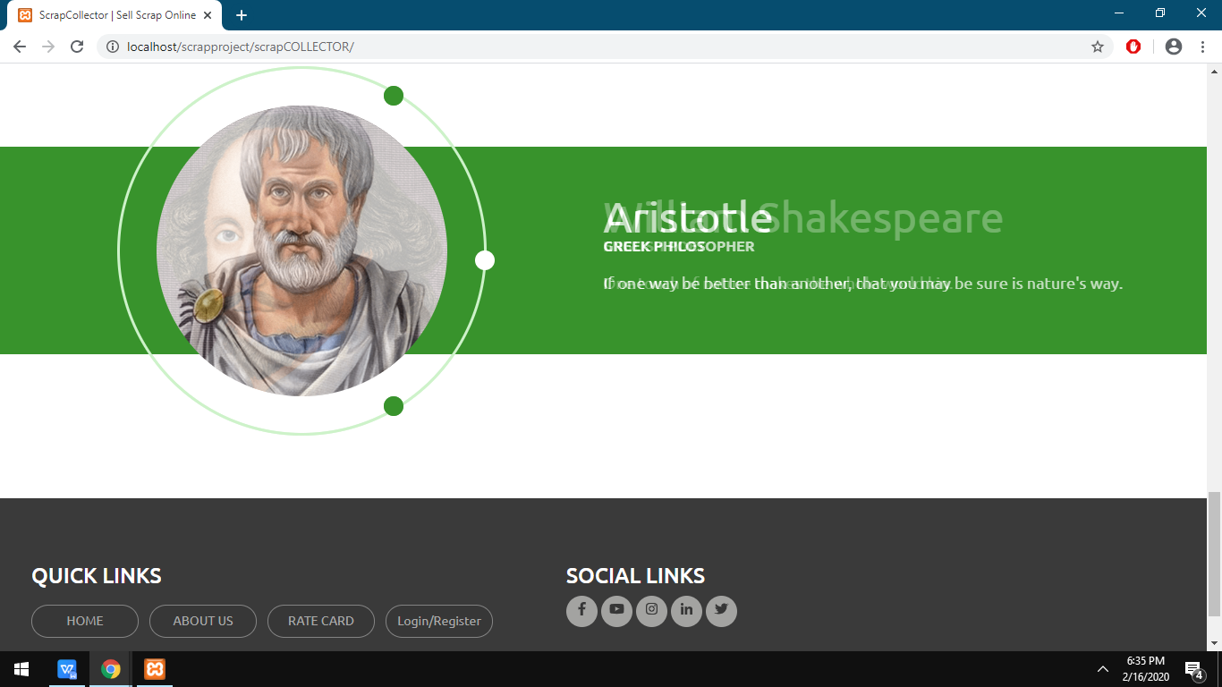

**RATE CARD PAGE :**

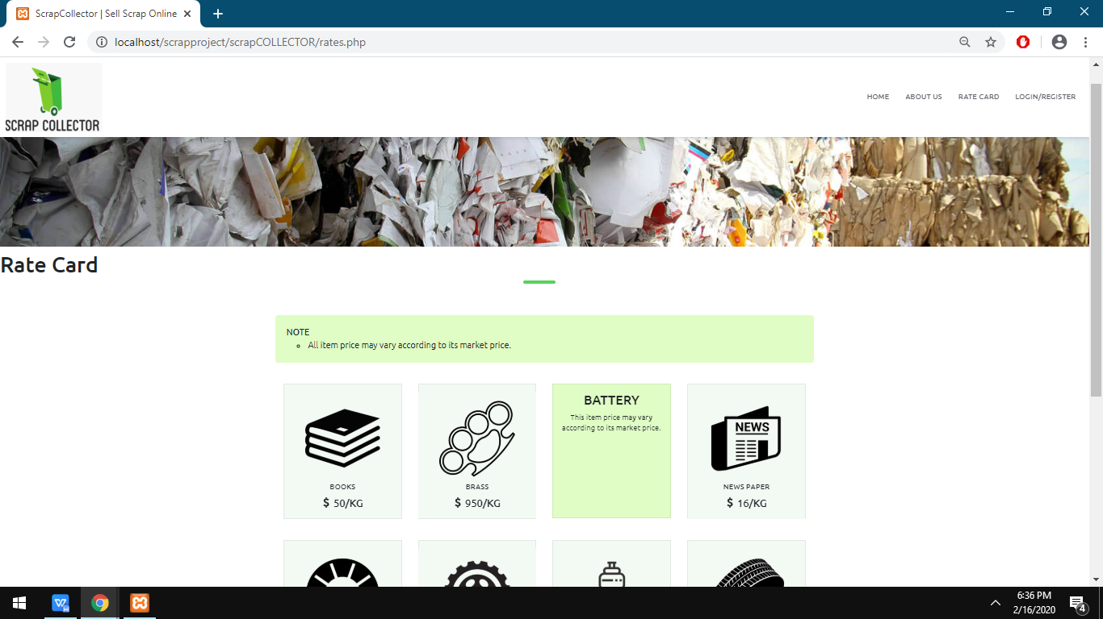

**LOGIN PAGE:**

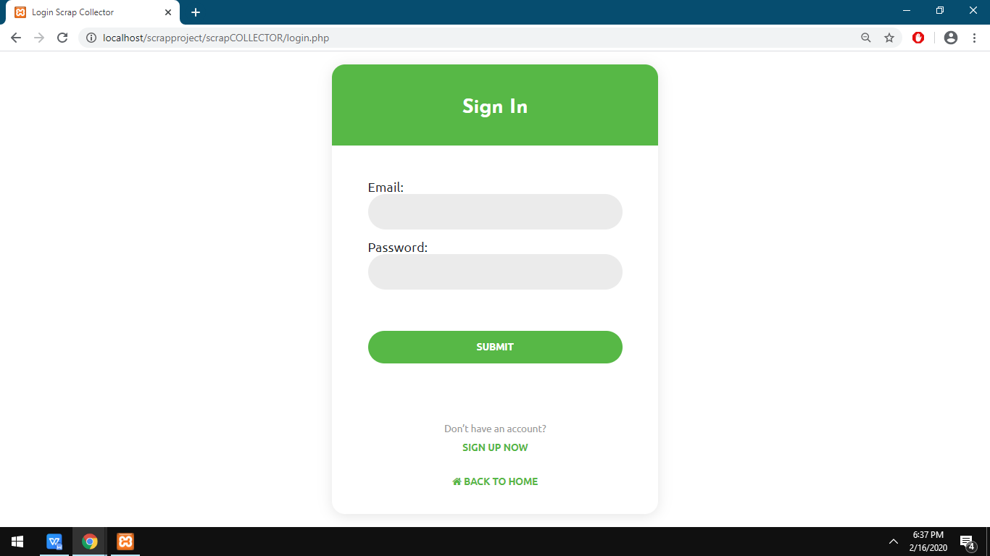

**SIGN UP PAGE:**

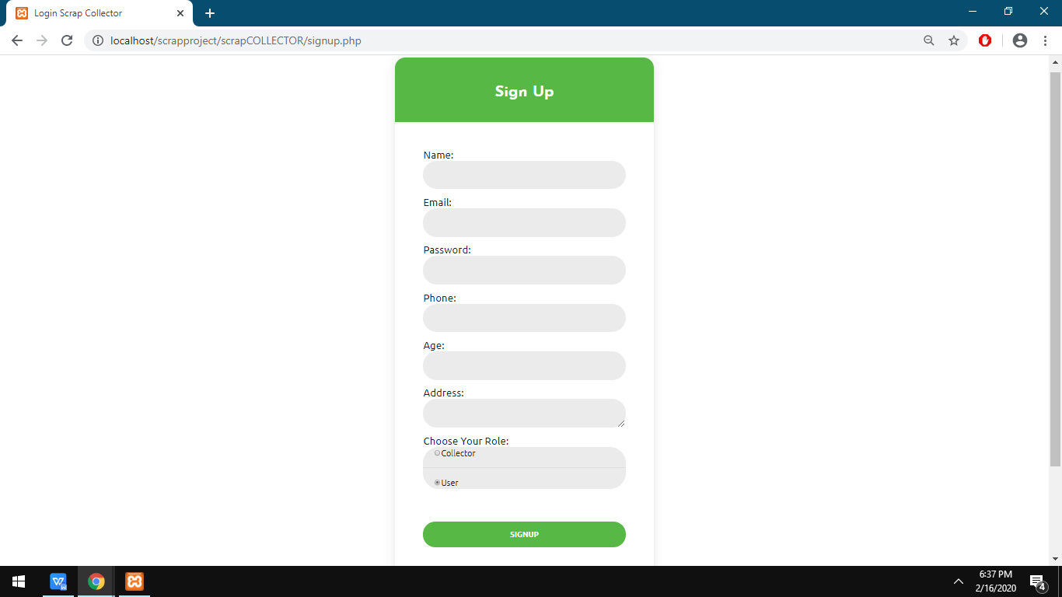

**USER PROFILE UPDATE PAGE:**

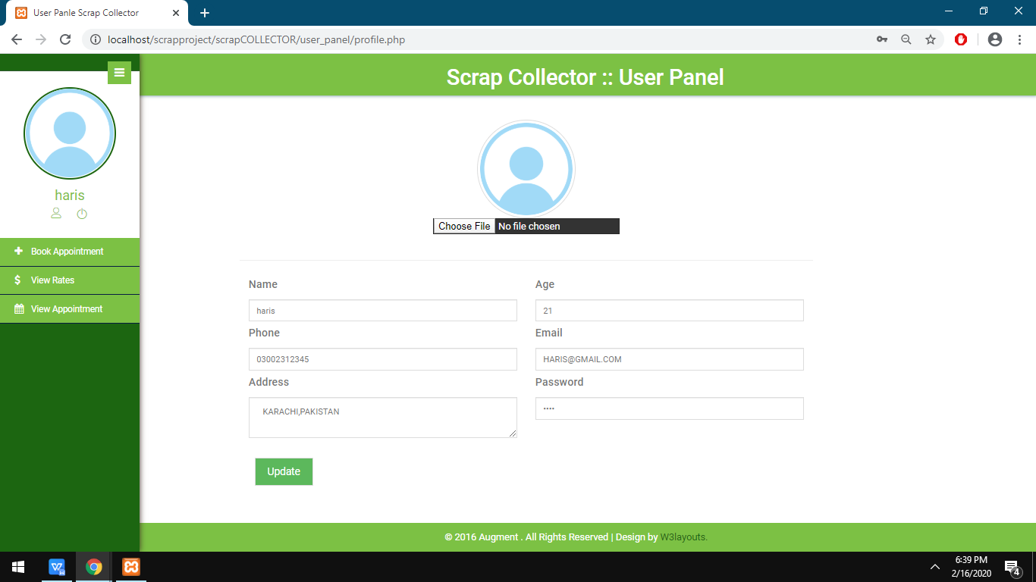

**Appointment booking page:**

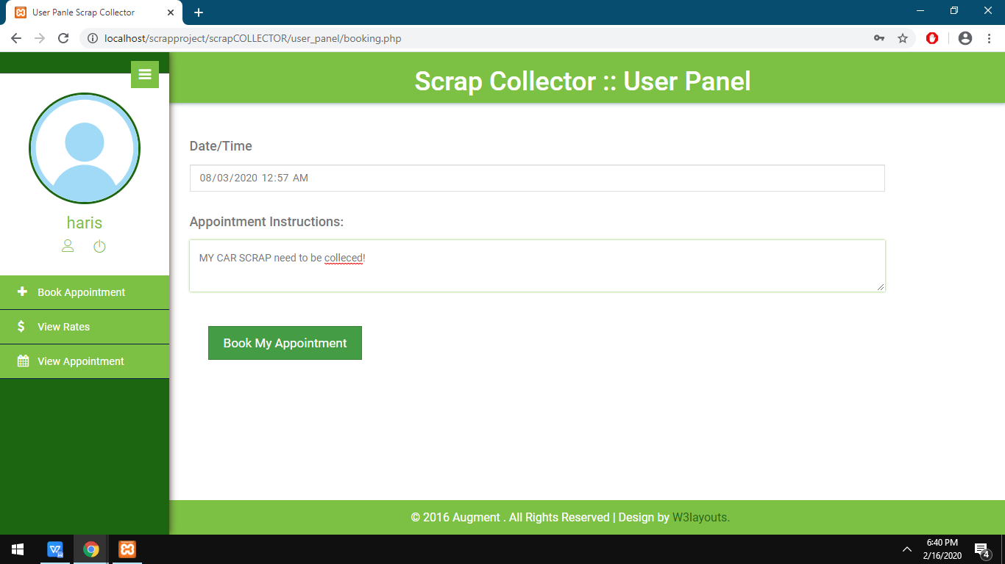

**RATES VIEW PAGE FOR USER:**

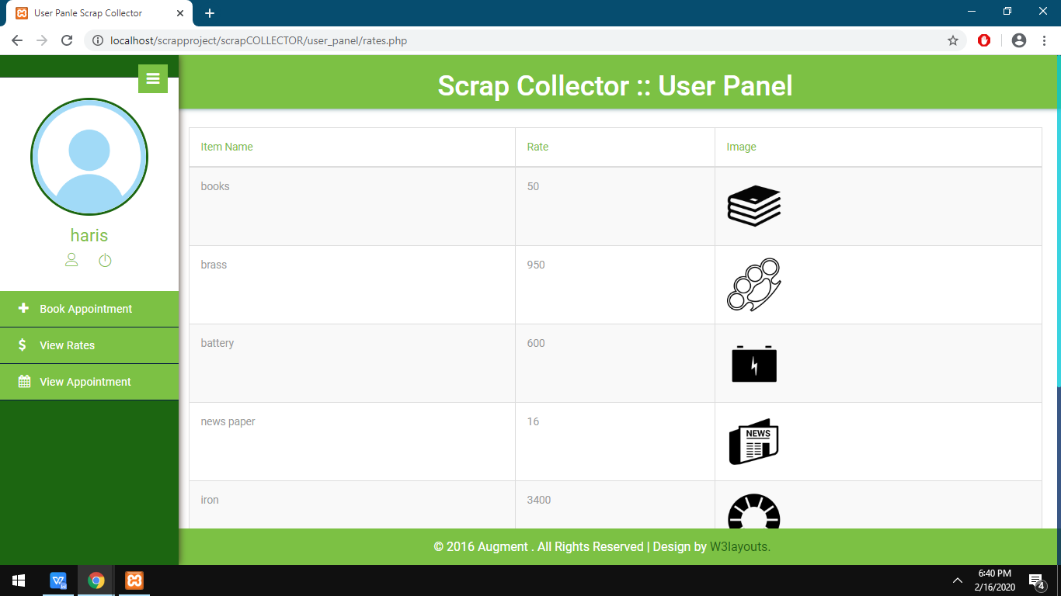

**USER SCRAP SELLING DETAILS PAGE:**

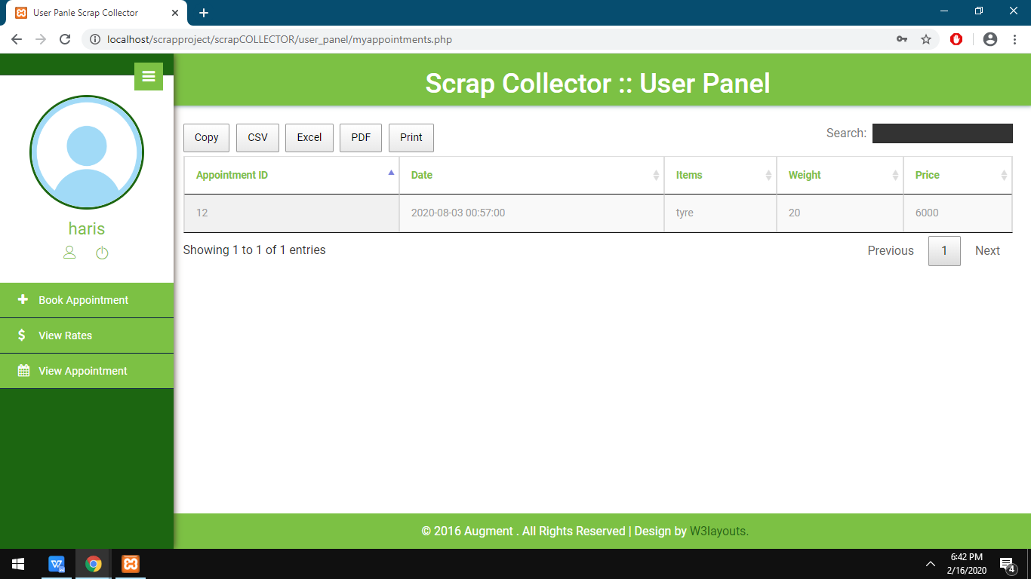

**SCRAP ITEM EDIT/ADD PAGE:**

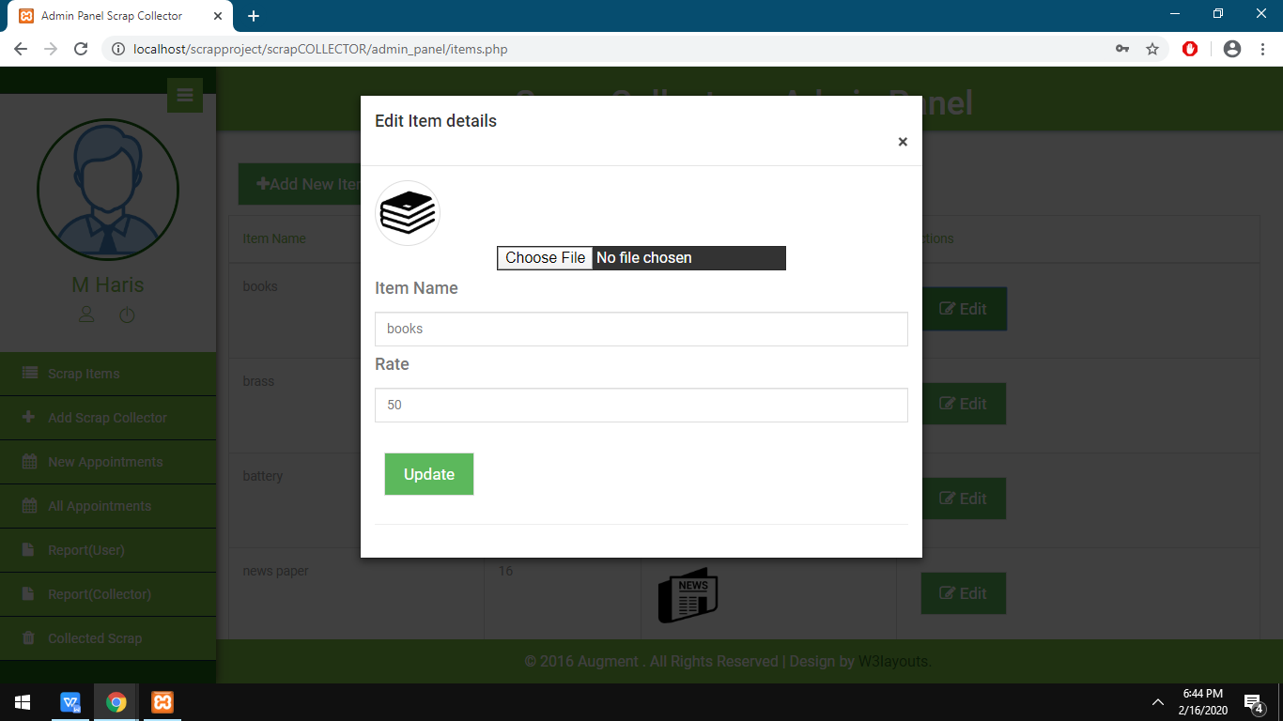

**ADD SCRAP COLLECTOR PAGE FOR ADMIN:**

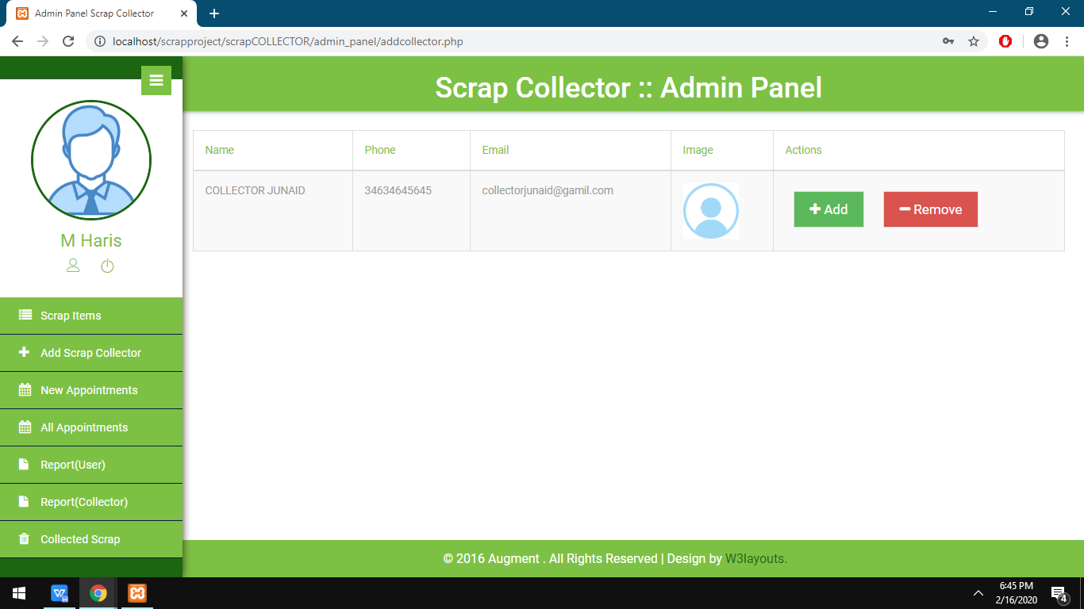

**ASSIGN APPOINTMENTS TO SCRAP COLLECTOR PAGE:**

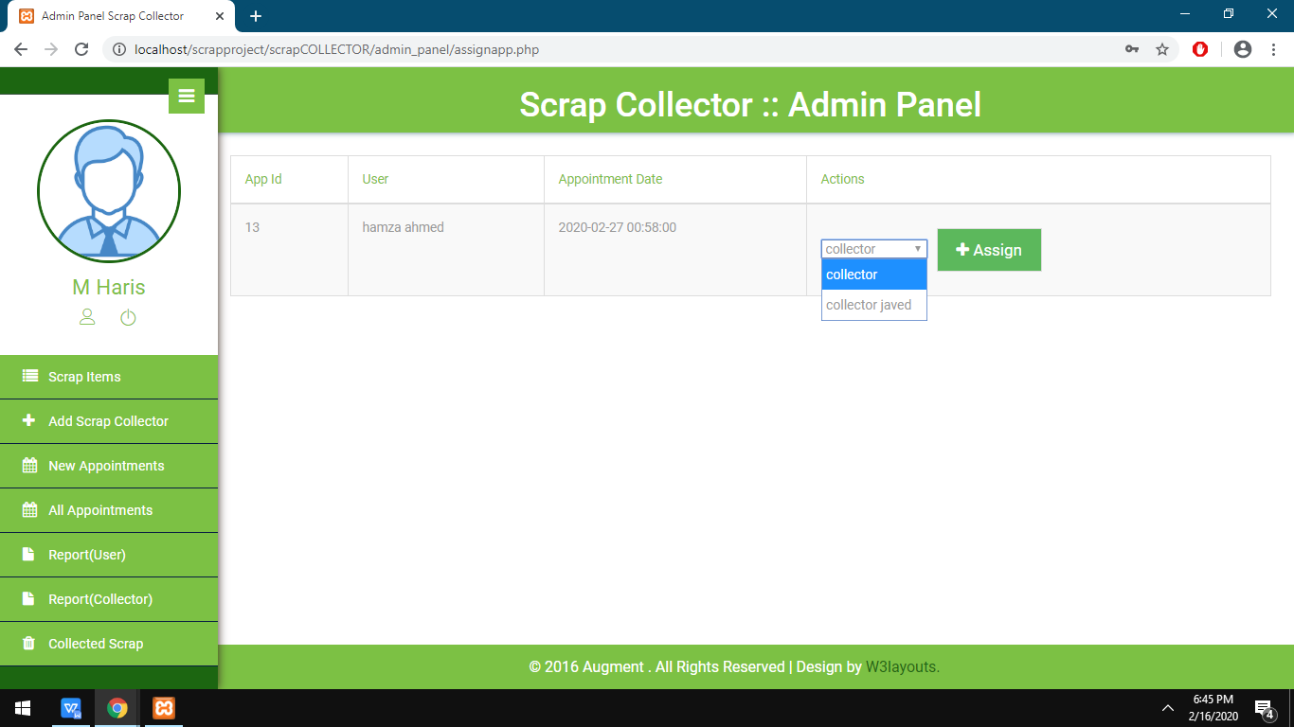

**ALL APOINTMENTS PAGE:**

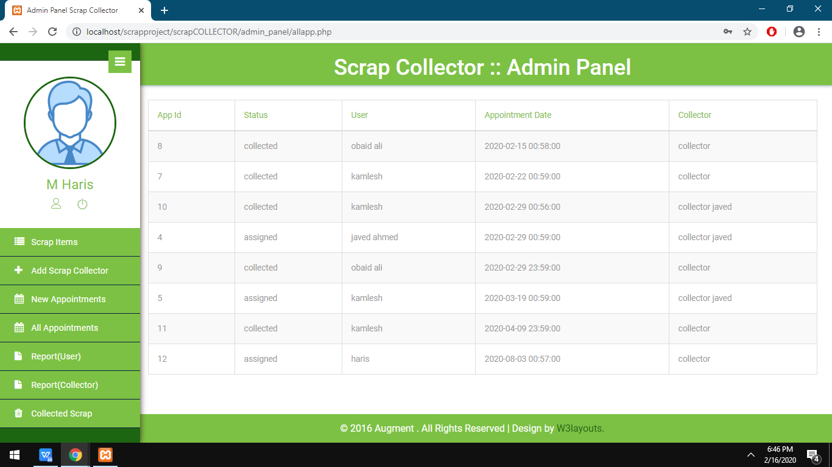

**USER WISE REPRT PAGE:**

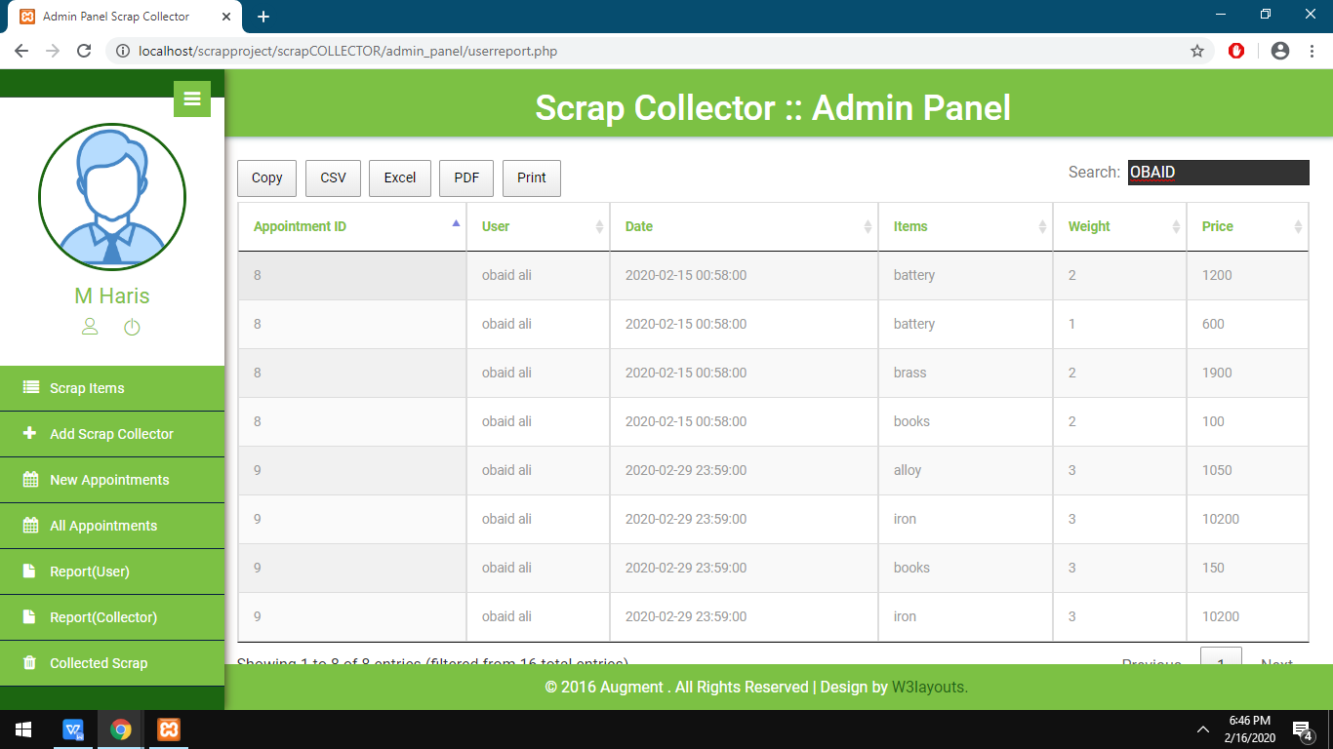

**COLLECTOR WISE REPORT PAGE:**

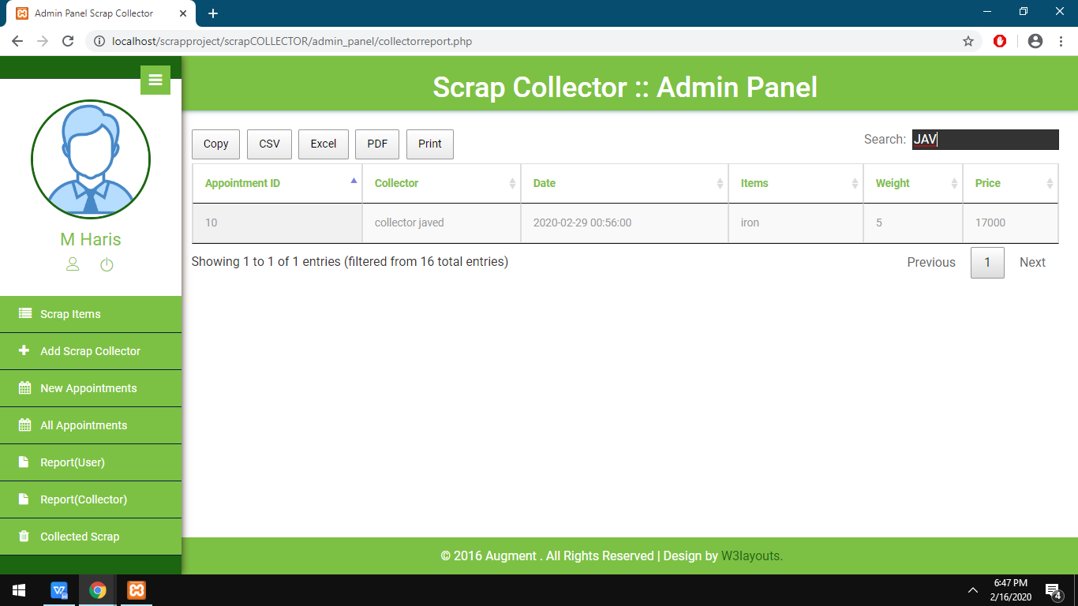

**DATE WISE COLLECTED SCRAP :**

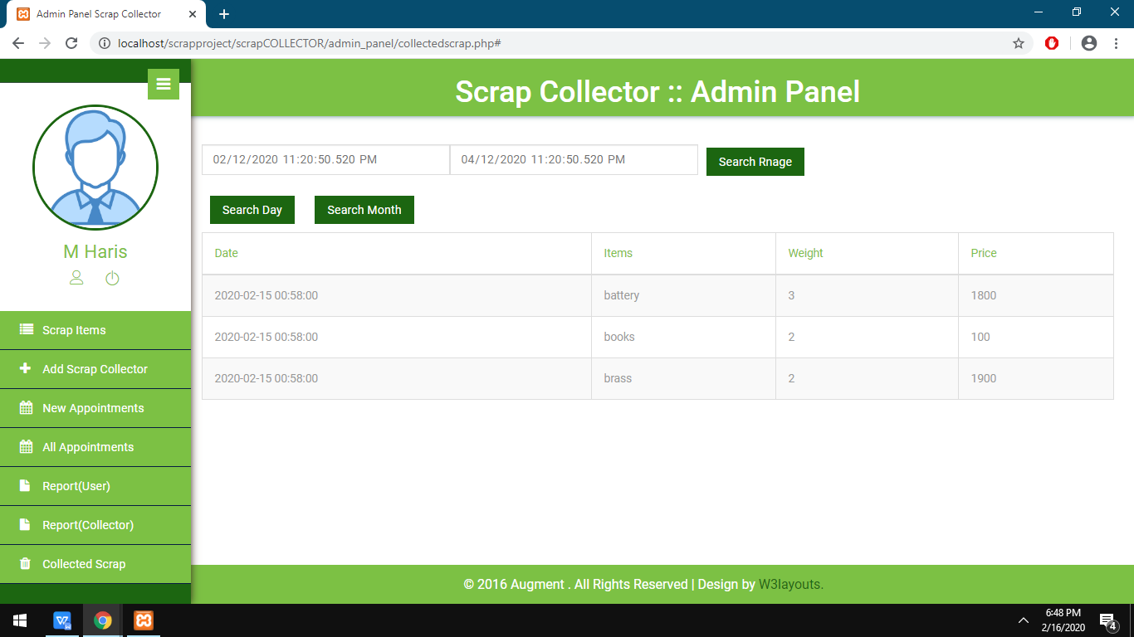

**ASSIGNED APPOINTMENT PAGE FOR COLLECTOR:**

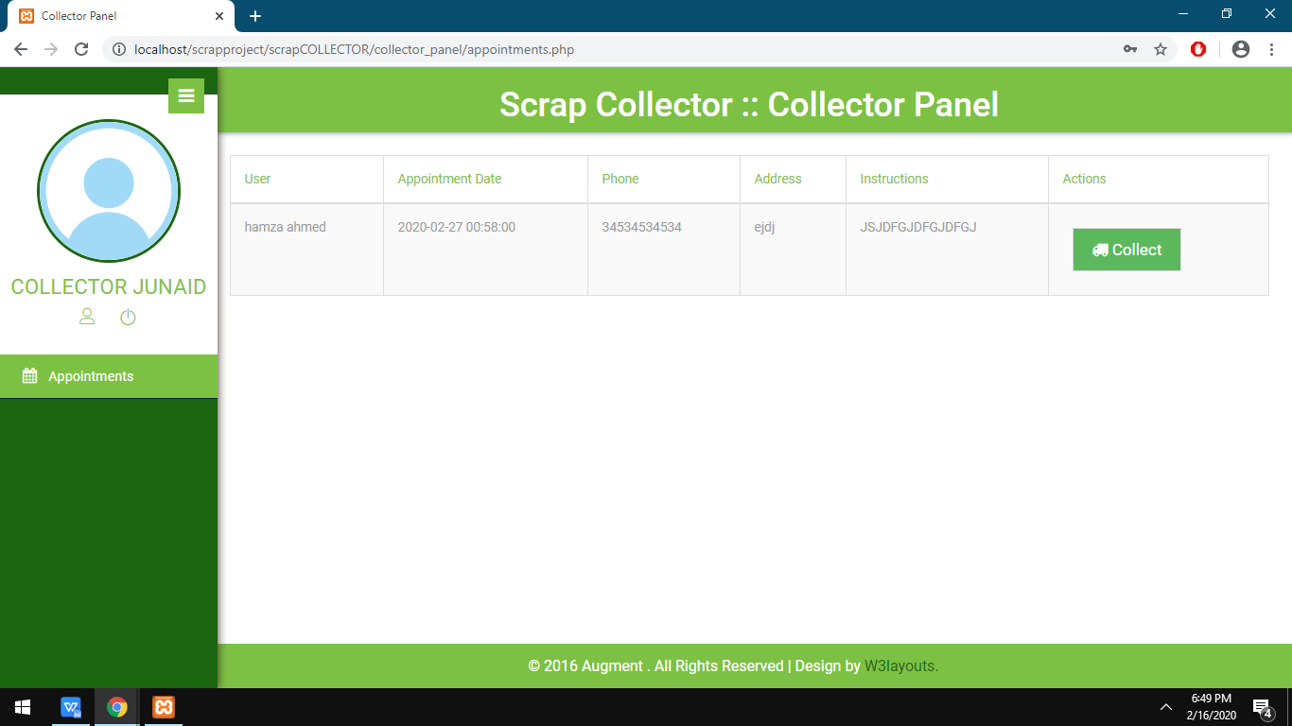

**ADD COLLECTED ITEM DWETAILS TO DATABASE FOR APPOINTMENT:**

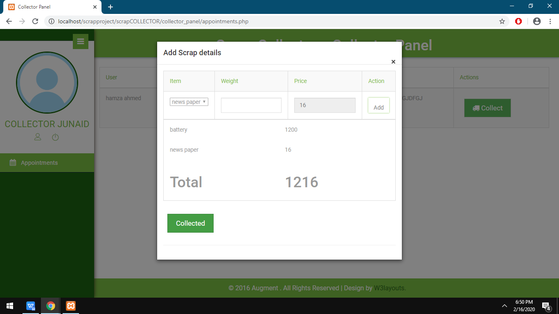

:

TING CHECK LIST AN

D TASK SHEET

|  |  |
| --- | --- |
| **Task** |  |
| DESIGN |  |
| DATABASE |  |
| Coding |  |
| Testing |  |
| Documentation |  |

**UNIT TESTING CHECK LIST AND TASK SHEET**

|  |  |
| --- | --- |
| **MODULE** | **STATUS** |
| Login |  |
| ADMIN PANEL |  |
| USER PANEL |  |
| CCOLLECTOR PANEL |  |
| Website |  |
| validations |  |